Steven Nguyen

Professor Costarella

L7MVC

Grade Screenshot

3/12/2021

These are all the original (kind of…I sort of messed with it a bit and forgot to screenshot the original, but this is the closest it was)

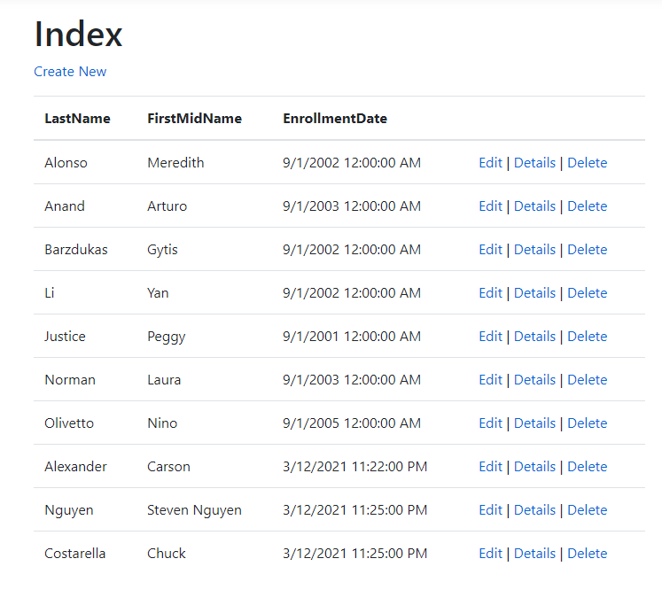

The following two screen shots are of the Last Name changes to both Chuck’s and mine name.

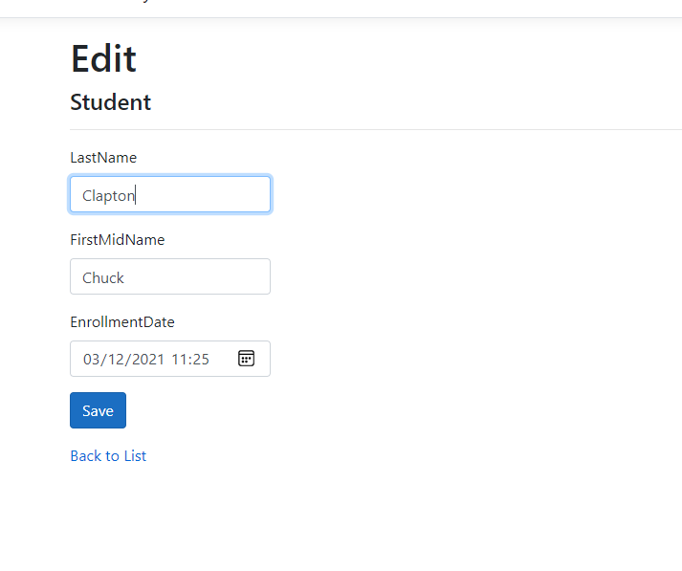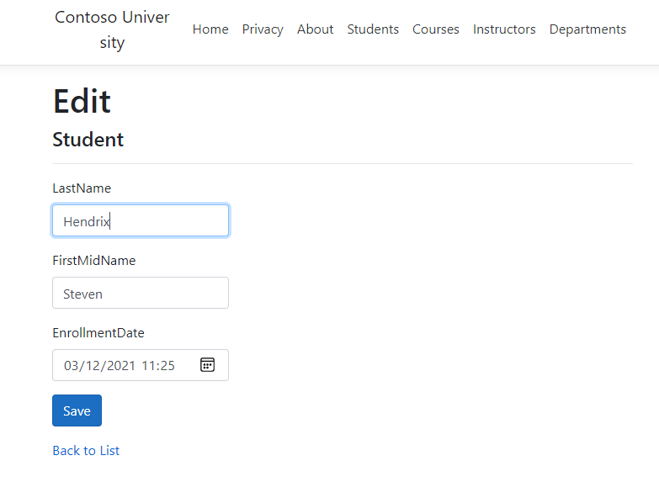

The following is the new updated list after editing both Professor Costeralla’s name and mine as well.

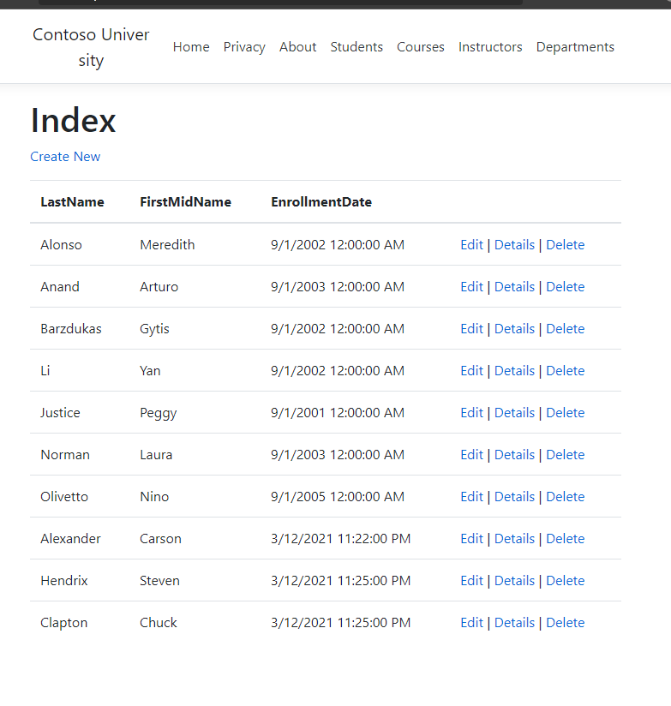

The following is the SQL Data table within VS itself. Showcasing off the data points

